GoGlobal Travel XML interface
v3.1



Test Plan Document (v3.1) for
Production Certification

Index:
TEST Page
General Information 3
TP 1 - Hotel search with mixed room types. 4
TP 2 - Hotel search with identical rooms. 5
TP 3 - Hotel search with children. 6
TP 4 - Hotel search with search remark. 7
TP 5 - Hotel Price Breakdown 8
TP 6 - New remark and Cancellation Deadline in valuation. 9
TP 7 - Check Booking, Status and Cancel booking. 10
TP 8 - Check Booking, Status and issue Voucher. 11
TP 9 - Hotel info. 12
General Information
Test web service address
http://xml.qa.goglobal.travel/XMLWebService.asmx
** Use same credentials used for development
** For verification and certification purposes, for all tests you should send to GoGlobal:
1. Access credentials for your test env (when possible)
2. Screenshots for:
- Search & Results Interface (including room selection)
- Booking Valuation Information
- Price Breakdown.
- Booking Interface – pax details, etc.
- Booking Confirmation Interface
- Booking Status Interface
- Booking Voucher
- Booking Cancellation Interface
- Hotel Details Interface (incl. Photos and any other info)
** At the end of every test - cancel the tested booking
** If you cannot complete a test due to tech limitation/business logic on your side, please advise so on the test page.
** Contact details for questions: lior@goglobal.travel
TP #1 Hotel Search with mixed room types
Objective: Impement individual search per room (recommended for better performance)
OR
Check that you get hotel availability with mixed room types
Description:
- Execute HOTEL_SEARCH_REQUEST method with the below params:

Destination: AMSTERDAM/ City Code=75 (NETHERLANDS)

Check In: 26/10/2015
Nights: 1
Room(s): 1 adult + 2 adults + 3 adults

Hotel Name: “BEST WESTERN LEIDSE SQUARE” (hotel code: 268)
Select room type:
“2 Single Beds Non-Smoking,1 Double Bed Non-Smoking,2 Single Beds Non-Smoking Family Room 3rd Bed Is A Single Bed”
Room Basis: RO

OR

Hotel Name: “TULIP INN CITY WEST” (hotel code: 274)
Select room type: “DOBLEUSO (PARA 1 PERS),TWIN (DOBLE 2 CAMAS),TRIPLE”
Room Basis: RO

Please make sure to add:
- Screenshot with your params and the hotel from the returned Hotel search response
- request/response XML
TP #2 Hotel Search with identical rooms
Objective: Impement individual search per room (recommended for better performance)
OR
Check that you get hotel availability for multiple identical rooms.
Description:
- Execute HOTEL_SEARCH_REQUEST method with the below params:
Destination: DHAKA/ City Code=3715 (BANGLADESH)
Check In: 26/10/2015
Nights: 3
Room(s): 3 rooms for 2 adults

Hotel Name: “TESTJUNE (TEST HOTEL)” (hotel code: 88752)
Select room type: “CLUB SEA VIEW”
Room Basis: BB

Please make sure to add:
- Screenshot with your params and the hotel from the returned Hotel search response
- request/response XML
TP #3 Hotel Search with children
Objective: Check that you get hotel availability with children.
Description:
- Execute HOTEL_SEARCH_REQUEST method with the below params:
Destination: PARIS/ City Code=1459 (FRANCE)
Check In: 26/10/2015
Nights: 3
Room(s): 1 adult + 2 children age: 7, 6.
Hotel Name: “CITEA PARIS QUAI D`IVRY” (hotel code: 112571)
Please make sure to add:
- Screenshot with your params and the hotel from the returned Hotel search response
- request/response XML
*** Please do not book this hotel!!! ***
TP #4 Hotel Search with Remark
Objective: Check you get and display remarks from hotel availability.
Description:
- Execute HOTEL_SEARCH_REQUEST method with the below params:

Destination: AMSTERDAM/ City Code=75 (NETHERLANDS)
Check in: 26/10/2015
Nights: 3
Room(s): 1 room for 2 adults
Hotel Name: “OKURA” (hotel code: 13324)
Remark: "THE HOTEL IS A NON-SMOKING PROPERTY"

Please make sure to add:
- Screenshot with your params and the hotel from the returned Hotel search response
- request/response XML
*** Please Do not book this hotel!!! ***
TP #5 Hotel Price Breakdown
Objective: Check you get and display price breakdown
Description:
- Execute HOTEL_SEARCH_REQUEST method with the below params:

Destination: AMSTERDAM/ City Code=75 (NETHERLANDS)
Check in: 26/10/2015
Nights: 3
Room(s): 2 adults + 1 adult
Hotel Name: “TULIP INN CITY WEST” (hotel code: 274)
Select room type: “TWIN (DOBLE 2 CAMAS),DOBLEUSO (PARA 1 PERS)”
Room Basis: BB

- Execute PRICE_BREAKDOWN_REQUEST method with received HotelSearchCode

Please make sure to add:
- Screenshot with your params and the hotel from the returned Hotel search response
- Details of price breakdown of returned hotel and room prices
- request/response XML
*** Please Do not book this hotel!!! ***
TP #6 Booking Valuation
Objective: Check additional remarks and changes in cancellation deadline in valuation response.
Description:
- Execute HOTEL_SEARCH_REQUEST method with the below params:
- Execute BOOKING_VALUATION_REQUEST method with received HotelSearchCode
- Check for additional remark, the remark should be: "STARTING 23/10/2015 CXL-PENALTY FEE IS 1 NIGHTS"
- Check for changes in cancellation deadline (2015-10-23)
Destination: AMSTERDAM/ City Code=75 (NETHERLANDS)
Check In: 26/10/2015
Nights: 3
Room(s): 2 adults

Hotel Name: “IBIS AMSTERDAM CITY WEST” (hotelcode: 31530)
Select room type: “STANDARD”

Please make sure to add -
- Screenshot with your params and the hotel from the returned Hotel search response
- 6.1 Screenshot with your params
- 6.2 Screenshot hotel search response
- 6.2 Screenshot hotel IBIS AMSTERDAM CITY WEST
- Screenshot with remark after booking valuation
- Screenshot with cancellation Deadline after booking valuation.
- REQ and RES of the whole process.
*** Please Do not book this hotel!!! ***
TP #7 Insert Booking, Booking Status, Booking Cancel
Objective: check full process of hotel booking, status check and cancellation.
Description:
- Execute HOTEL_SEARCH_REQUEST method with the below params:
- Execute BOOKING_INSERT_REQUEST method using HotelSearchCode.value.
- Execute BOOKING_STATUS_REQUEST method using GoBookingCode value.
- Execute BOOKING_CANCEL_REQUEST method using GoBookingCode value.
- Execute BOOKING_STATUS_REQUEST method again using GoBookingCode value.
Destination: DHAKA/ City Code=3715 (BANGLADESH)
Check In: 26/10/2015
Nights: 3
Room(s): 2 adults

Hotel Name: “TESTJUNE (TEST HOTEL)” (hotel code: 88752)
Select room type: “CLUB SEA VIEW”
Room Basis: BB

Please make sure to add -
- 7.1 Screenshot with your params and the hotel from the returned
- 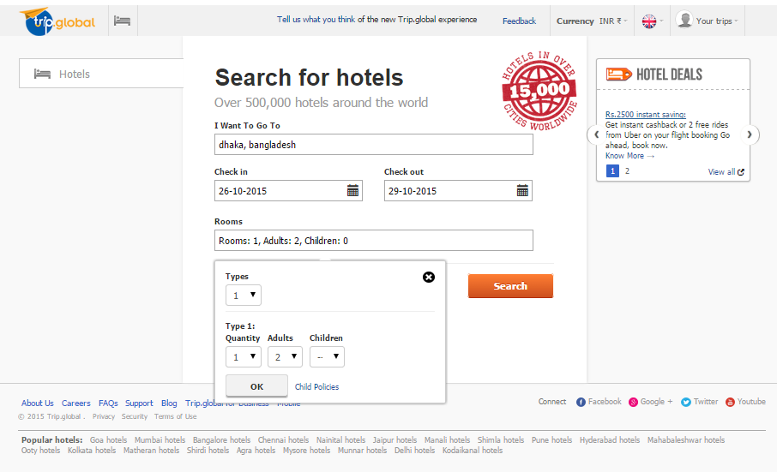
- 7.1.1 Screenshot with your params
- 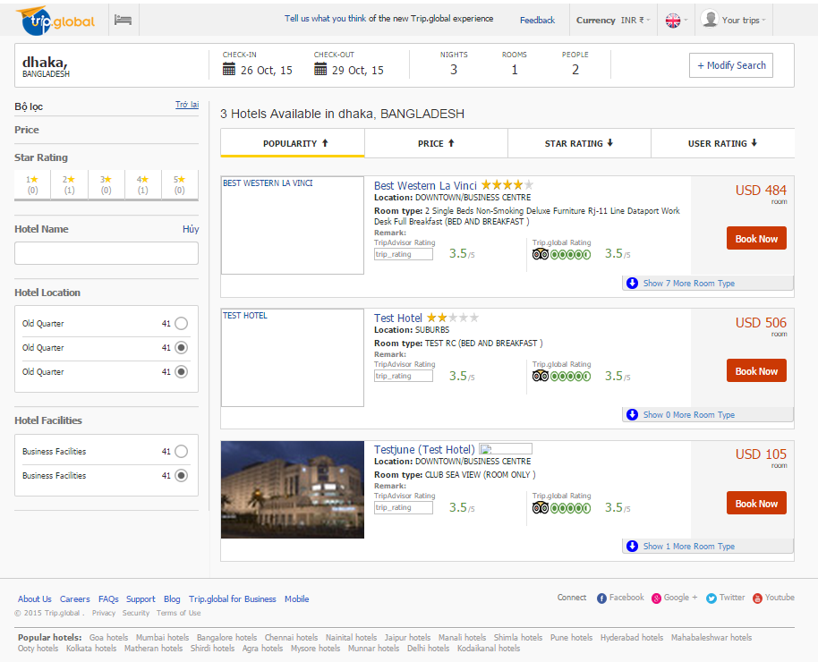
- 7.1.2 Screenshot hotel search response

- 7.2 Screenshot with booking info after Booking Insert
- 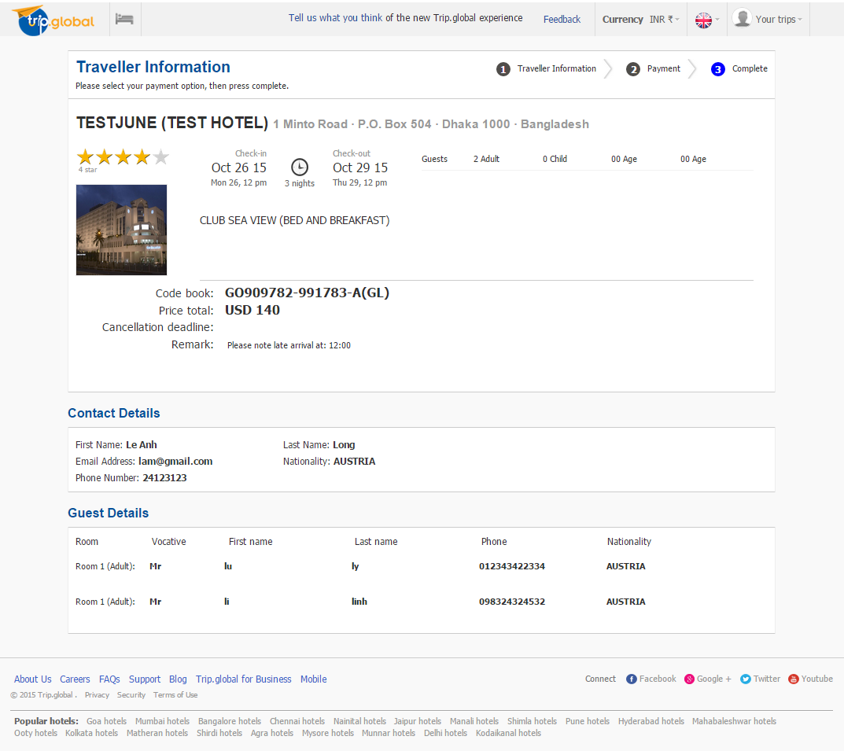
- 7.3 Screenshot with booking info after Booking Status
- 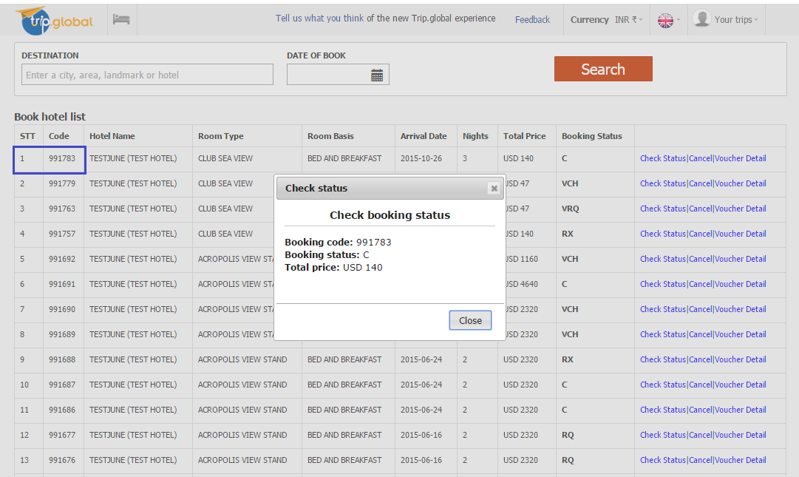
- 7.4 Screenshot with booking info after Cancel
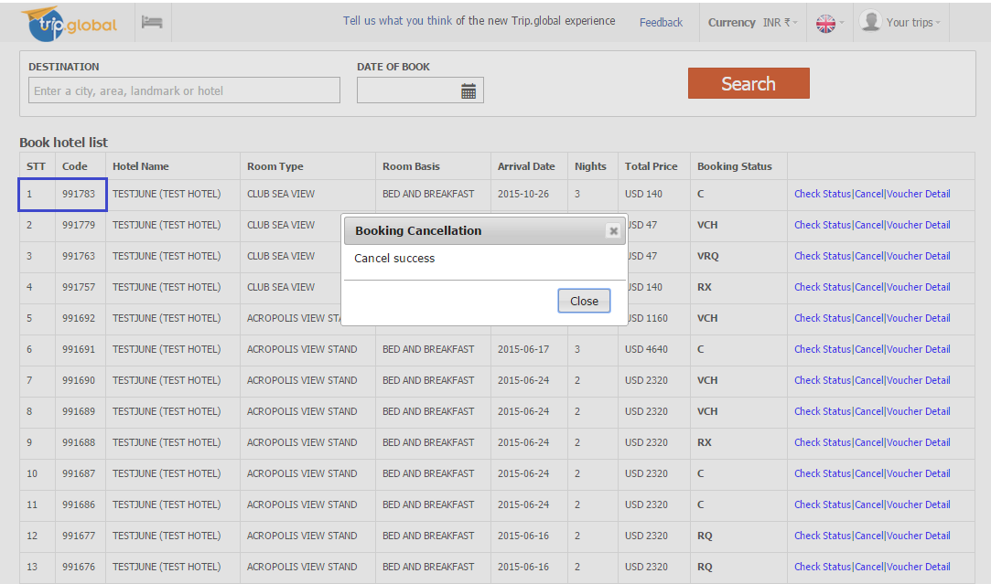

- 7.5 Screenshot with booking info after 2nd Booking Status
- 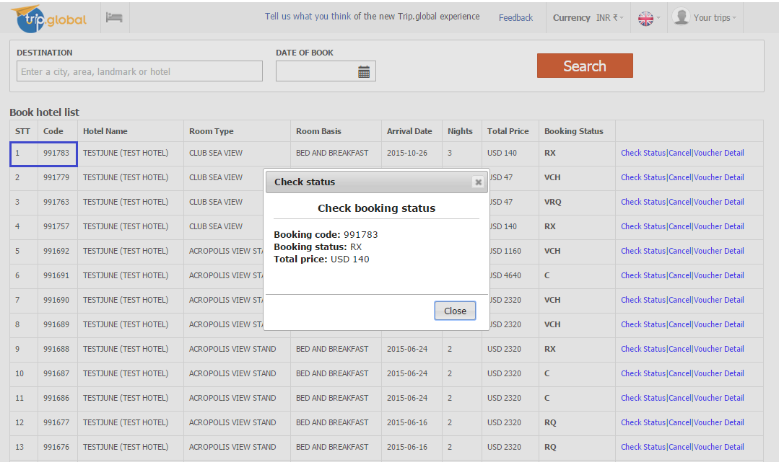
- Req/Res for whole process.
- 7.1 Search hotel
- a. Request xml
<?xml version="1.0" encoding="utf-8" ?>
<soap:Envelope xmlns:xsi="http://www.w3.org/2001/XMLSchema-instance" xmlns:xsd="http://www.w3.org/2001/XMLSchema" xmlns:soap="http://schemas.xmlsoap.org/soap/envelope/">
<soap:Body>
<MakeRequest xmlns="http://www.goglobal.travel/">
<requestType>11</requestType>
<xmlRequest>
<![CDATA[ <Root> <Header> <Agency>1521345</Agency> <User>TRIPGLOBALXML</User> <Password>XMLTRIPGLOBAL</Password> <Operation>HOTEL_SEARCH_REQUEST</Operation> <OperationType>Request</OperationType> </Header> <Main> <SortOrder>0</SortOrder> <FilterPriceMin>0</FilterPriceMin> <FilterPriceMax>10000</FilterPriceMax> <MaximumWaitTime>30</MaximumWaitTime> <MaxResponses>1000</MaxResponses> <FilterRoomBasises> <FilterRoomBasis></FilterRoomBasis> </FilterRoomBasises> <HotelName></HotelName> <Apartments>false</Apartments> <CityCode>3715</CityCode> <ArrivalDate>2015-10-26</ArrivalDate> <Nights>3</Nights> <Rooms><Room Adults='2' RoomCount='1'></Room> </Rooms> </Main> </Root>]]>
</xmlRequest>
</MakeRequest>
</soap:Body>
- </soap:Envelope>
- b. Response xml
<?xml version="1.0" encoding="utf-8" ?>
<soap:Envelope xmlns:soap="http://schemas.xmlsoap.org/soap/envelope/" xmlns:xsi="http://www.w3.org/2001/XMLSchema-instance" xmlns:xsd="http://www.w3.org/2001/XMLSchema">
<soap:Body>
<MakeRequestResponse xmlns="http://www.goglobal.travel/">
<MakeRequestResult><Root><Header><Agency>1521345</Agency><User>TRIPGLOBALXML</User><Password>XMLTRIPGLOBAL</Password><Operation>HOTEL_SEARCH_RESPONSE</Operation><OperationType>Response</OperationType><Statistics><ResultsQty>11</ResultsQty></Statistics></Header><Main><Hotel><HotelSearchCode><![CDATA[220733/839860/0]]></HotelSearchCode><HotelCode><![CDATA[95509]]></HotelCode><HotelName><![CDATA[BEST WESTERN LA VINCI]]></HotelName><CountryId><![CDATA[139]]></CountryId><CxlDeadline><![CDATA[23/Oct/2015]]></CxlDeadline><RoomType><![CDATA[2 Single Beds Non-Smoking Deluxe Furniture Rj-11 Line Dataport Work Desk Full Breakfast]]></RoomType><RoomBasis><![CDATA[BB]]></RoomBasis><Availability><![CDATA[1]]></Availability><TotalPrice><![CDATA[484]]></TotalPrice><Currency><![CDATA[USD]]></Currency><Category><![CDATA[4]]></Category><Location><![CDATA[DOWNTOWN/BUSINESS CENTRE]]></Location><LocationCode><![CDATA[]]></LocationCode><Preferred><![CDATA[0]]></Preferred><Thumbnail><![CDATA[]]></Thumbnail><TripAdvisor><Rating></Rating><RatingImage><![CDATA[]]></RatingImage><ReviewCount></ReviewCount><Reviews><![CDATA[]]></Reviews></TripAdvisor></Hotel><Hotel><HotelSearchCode><![CDATA[220733/839860/1]]></HotelSearchCode><HotelCode><![CDATA[95509]]></HotelCode><HotelName><![CDATA[BEST WESTERN LA VINCI]]></HotelName><CountryId><![CDATA[139]]></CountryId><CxlDeadline><![CDATA[23/Oct/2015]]></CxlDeadline><RoomType><![CDATA[2 Single Beds Smoking Room City View Air-Conditioned Full Breakfast]]></RoomType><RoomBasis><![CDATA[BB]]></RoomBasis><Availability><![CDATA[1]]></Availability><TotalPrice><![CDATA[484]]></TotalPrice><Currency><![CDATA[USD]]></Currency><Category><![CDATA[4]]></Category><Location><![CDATA[DOWNTOWN/BUSINESS CENTRE]]></Location><LocationCode><![CDATA[]]></LocationCode><Preferred><![CDATA[0]]></Preferred><Thumbnail><![CDATA[]]></Thumbnail><TripAdvisor><Rating></Rating><RatingImage><![CDATA[]]></RatingImage><ReviewCount></ReviewCount><Reviews><![CDATA[]]></Reviews></TripAdvisor></Hotel><Hotel><HotelSearchCode><![CDATA[220733/839860/2]]></HotelSearchCode><HotelCode><![CDATA[95509]]></HotelCode><HotelName><![CDATA[BEST WESTERN LA VINCI]]></HotelName><CountryId><![CDATA[139]]></CountryId><CxlDeadline><![CDATA[23/Oct/2015]]></CxlDeadline><RoomType><![CDATA[1 Double Bed Smoking Room City View Air-Conditioned Full Breakfast]]></RoomType><RoomBasis><![CDATA[BB]]></RoomBasis><Availability><![CDATA[1]]></Availability><TotalPrice><![CDATA[484]]></TotalPrice><Currency><![CDATA[USD]]></Currency><Category><![CDATA[4]]></Category><Location><![CDATA[DOWNTOWN/BUSINESS CENTRE]]></Location><LocationCode><![CDATA[]]></LocationCode><Preferred><![CDATA[0]]></Preferred><Thumbnail><![CDATA[]]></Thumbnail><TripAdvisor><Rating></Rating><RatingImage><![CDATA[]]></RatingImage><ReviewCount></ReviewCount><Reviews><![CDATA[]]></Reviews></TripAdvisor></Hotel><Hotel><HotelSearchCode><![CDATA[220733/839860/3]]></HotelSearchCode><HotelCode><![CDATA[95509]]></HotelCode><HotelName><![CDATA[BEST WESTERN LA VINCI]]></HotelName><CountryId><![CDATA[139]]></CountryId><CxlDeadline><![CDATA[23/Oct/2015]]></CxlDeadline><RoomType><![CDATA[2 Single Beds Smoking Room Deluxe Furnishings Mini Bar Hairdryer Full Breakfast]]></RoomType><RoomBasis><![CDATA[BB]]></RoomBasis><Availability><![CDATA[1]]></Availability><TotalPrice><![CDATA[484]]></TotalPrice><Currency><![CDATA[USD]]></Currency><Category><![CDATA[4]]></Category><Location><![CDATA[DOWNTOWN/BUSINESS CENTRE]]></Location><LocationCode><![CDATA[]]></LocationCode><Preferred><![CDATA[0]]></Preferred><Thumbnail><![CDATA[]]></Thumbnail><TripAdvisor><Rating></Rating><RatingImage><![CDATA[]]></RatingImage><ReviewCount></ReviewCount><Reviews><![CDATA[]]></Reviews></TripAdvisor></Hotel><Hotel><HotelSearchCode><![CDATA[220733/839860/4]]></HotelSearchCode><HotelCode><![CDATA[95509]]></HotelCode><HotelName><![CDATA[BEST WESTERN LA VINCI]]></HotelName><CountryId><![CDATA[139]]></CountryId><CxlDeadline><![CDATA[23/Oct/2015]]></CxlDeadline><RoomType><![CDATA[1 Double Bed Smoking Room Deluxe Furnishings Mini Bar Hairdryer Full Breakfast]]></RoomType><RoomBasis><![CDATA[BB]]></RoomBasis><Availability><![CDATA[1]]></Availability><TotalPrice><![CDATA[484]]></TotalPrice><Currency><![CDATA[USD]]></Currency><Category><![CDATA[4]]></Category><Location><![CDATA[DOWNTOWN/BUSINESS CENTRE]]></Location><LocationCode><![CDATA[]]></LocationCode><Preferred><![CDATA[0]]></Preferred><Thumbnail><![CDATA[]]></Thumbnail><TripAdvisor><Rating></Rating><RatingImage><![CDATA[]]></RatingImage><ReviewCount></ReviewCount><Reviews><![CDATA[]]></Reviews></TripAdvisor></Hotel><Hotel><HotelSearchCode><![CDATA[220733/839860/5]]></HotelSearchCode><HotelCode><![CDATA[95509]]></HotelCode><HotelName><![CDATA[BEST WESTERN LA VINCI]]></HotelName><CountryId><![CDATA[139]]></CountryId><CxlDeadline><![CDATA[23/Oct/2015]]></CxlDeadline><RoomType><![CDATA[1 Double Bed Non-Smoking Deluxe Furniture Rj-11 Line Dataport Work Desk Full Breakfast]]></RoomType><RoomBasis><![CDATA[BB]]></RoomBasis><Availability><![CDATA[1]]></Availability><TotalPrice><![CDATA[484]]></TotalPrice><Currency><![CDATA[USD]]></Currency><Category><![CDATA[4]]></Category><Location><![CDATA[DOWNTOWN/BUSINESS CENTRE]]></Location><LocationCode><![CDATA[]]></LocationCode><Preferred><![CDATA[0]]></Preferred><Thumbnail><![CDATA[]]></Thumbnail><TripAdvisor><Rating></Rating><RatingImage><![CDATA[]]></RatingImage><ReviewCount></ReviewCount><Reviews><![CDATA[]]></Reviews></TripAdvisor></Hotel><Hotel><HotelSearchCode><![CDATA[220733/839860/6]]></HotelSearchCode><HotelCode><![CDATA[95509]]></HotelCode><HotelName><![CDATA[BEST WESTERN LA VINCI]]></HotelName><CountryId><![CDATA[139]]></CountryId><CxlDeadline><![CDATA[23/Oct/2015]]></CxlDeadline><RoomType><![CDATA[Suite-1 Room 1 Bed Smoking Room Deluxe Furnishings Mini Bar Hairdryer Full Breakfast]]></RoomType><RoomBasis><![CDATA[BB]]></RoomBasis><Availability><![CDATA[1]]></Availability><TotalPrice><![CDATA[528]]></TotalPrice><Currency><![CDATA[USD]]></Currency><Category><![CDATA[4]]></Category><Location><![CDATA[DOWNTOWN/BUSINESS CENTRE]]></Location><LocationCode><![CDATA[]]></LocationCode><Preferred><![CDATA[0]]></Preferred><Thumbnail><![CDATA[]]></Thumbnail><TripAdvisor><Rating></Rating><RatingImage><![CDATA[]]></RatingImage><ReviewCount></ReviewCount><Reviews><![CDATA[]]></Reviews></TripAdvisor></Hotel><Hotel><HotelSearchCode><![CDATA[220733/839860/7]]></HotelSearchCode><HotelCode><![CDATA[95509]]></HotelCode><HotelName><![CDATA[BEST WESTERN LA VINCI]]></HotelName><CountryId><![CDATA[139]]></CountryId><CxlDeadline><![CDATA[23/Oct/2015]]></CxlDeadline><RoomType><![CDATA[Suite-1 Room 1 Bed Non-Smoking Deluxe Furniture Rj-11 Line Dataport Work Desk Full Breakfast]]></RoomType><RoomBasis><![CDATA[BB]]></RoomBasis><Availability><![CDATA[1]]></Availability><TotalPrice><![CDATA[528]]></TotalPrice><Currency><![CDATA[USD]]></Currency><Category><![CDATA[4]]></Category><Location><![CDATA[DOWNTOWN/BUSINESS CENTRE]]></Location><LocationCode><![CDATA[]]></LocationCode><Preferred><![CDATA[0]]></Preferred><Thumbnail><![CDATA[]]></Thumbnail><TripAdvisor><Rating></Rating><RatingImage><![CDATA[]]></RatingImage><ReviewCount></ReviewCount><Reviews><![CDATA[]]></Reviews></TripAdvisor></Hotel><Hotel><HotelSearchCode><![CDATA[128562/839860/8]]></HotelSearchCode><HotelCode><![CDATA[97296]]></HotelCode><HotelName><![CDATA[TEST HOTEL]]></HotelName><CountryId><![CDATA[139]]></CountryId><CxlDeadline><![CDATA[18/Oct/2015]]></CxlDeadline><RoomType><![CDATA[TEST RC]]></RoomType><RoomBasis><![CDATA[BB]]></RoomBasis><Availability><![CDATA[1]]></Availability><TotalPrice><![CDATA[506]]></TotalPrice><Currency><![CDATA[USD]]></Currency><Category><![CDATA[2]]></Category><Location><![CDATA[SUBURBS]]></Location><LocationCode><![CDATA[24672]]></LocationCode><Preferred><![CDATA[0]]></Preferred><Thumbnail><![CDATA[]]></Thumbnail><TripAdvisor><Rating></Rating><RatingImage><![CDATA[]]></RatingImage><ReviewCount></ReviewCount><Reviews><![CDATA[]]></Reviews></TripAdvisor></Hotel><Hotel><HotelSearchCode><![CDATA[147172/839860/9]]></HotelSearchCode><HotelCode><![CDATA[88752]]></HotelCode><HotelName><![CDATA[TESTJUNE (TEST HOTEL)]]></HotelName><CountryId><![CDATA[139]]></CountryId><CxlDeadline><![CDATA[17/Jul/2015]]></CxlDeadline><RoomType><![CDATA[CLUB SEA VIEW]]></RoomType><RoomBasis><![CDATA[RO]]></RoomBasis><Availability><![CDATA[1]]></Availability><TotalPrice><![CDATA[105]]></TotalPrice><Currency><![CDATA[USD]]></Currency><Category><![CDATA[3.5]]></Category><Location><![CDATA[DOWNTOWN/BUSINESS CENTRE]]></Location><LocationCode><![CDATA[21240]]></LocationCode><Preferred><![CDATA[0]]></Preferred><Thumbnail><![CDATA[http://images.static.goglobal.travel/images/hotels/88752/88752_3t.jpg]]></Thumbnail><GeoCodes><Longitude><![CDATA[90.397]]></Longitude><Latitude><![CDATA[23.74128]]></Latitude></GeoCodes><TripAdvisor><Rating></Rating><RatingImage><![CDATA[]]></RatingImage><ReviewCount></ReviewCount><Reviews><![CDATA[]]></Reviews></TripAdvisor></Hotel><Hotel><HotelSearchCode><![CDATA[147171/839860/10]]></HotelSearchCode><HotelCode><![CDATA[88752]]></HotelCode><HotelName><![CDATA[TESTJUNE (TEST HOTEL)]]></HotelName><CountryId><![CDATA[139]]></CountryId><CxlDeadline><![CDATA[25/Oct/2015]]></CxlDeadline><RoomType><![CDATA[CLUB SEA VIEW]]></RoomType><RoomBasis><![CDATA[BB]]></RoomBasis><Availability><![CDATA[1]]></Availability><TotalPrice><![CDATA[140]]></TotalPrice><Currency><![CDATA[USD]]></Currency><Category><![CDATA[3.5]]></Category><Location><![CDATA[DOWNTOWN/BUSINESS CENTRE]]></Location><LocationCode><![CDATA[21240]]></LocationCode><Preferred><![CDATA[0]]></Preferred><Thumbnail><![CDATA[http://images.static.goglobal.travel/images/hotels/88752/88752_3t.jpg]]></Thumbnail><GeoCodes><Longitude><![CDATA[90.397]]></Longitude><Latitude><![CDATA[23.74128]]></Latitude></GeoCodes><TripAdvisor><Rating></Rating><RatingImage><![CDATA[]]></RatingImage><ReviewCount></ReviewCount><Reviews><![CDATA[]]></Reviews></TripAdvisor></Hotel></Main></Root></MakeRequestResult>
</MakeRequestResponse>
</soap:Body>
- </soap:Envelope>
- 7.2 Booking info after Booking Insert
- a. Request xml
<?xml version="1.0" encoding="utf-8" ?>
<soap:Envelope xmlns:xsi="http://www.w3.org/2001/XMLSchema-instance" xmlns:xsd="http://www.w3.org/2001/XMLSchema" xmlns:soap="http://schemas.xmlsoap.org/soap/envelope/">
<soap:Body>
<MakeRequest xmlns="http://www.goglobal.travel/">
<requestType>2</requestType>
<xmlRequest>
<![CDATA[ <Root><Header> <Agency>1521345</Agency><User>TRIPGLOBALXML</User><Password>XMLTRIPGLOBAL</Password><Operation>BOOKING_INSERT_REQUEST</Operation><OperationType>Request</OperationType> </Header><Main><AgentReference>TRIPGLOBALXML</AgentReference><HotelSearchCode>147171/841960/10</HotelSearchCode><ArrivalDate>2015-10-26</ArrivalDate><Nights>3</Nights><NoAlternativeHotel>1</NoAlternativeHotel><Leader LeaderPersonID='1'/><Rooms><RoomType Adults='2' > <Room RoomID='1'><PersonName PersonID='1'>lu ly Mr </PersonName><PersonName PersonID='2'>li linh Mr </PersonName></Room></RoomType> </Rooms><Preferences><LateArrival>12:00</LateArrival><AdjoiningRooms>1</AdjoiningRooms><ConnectingRooms>1</ConnectingRooms></Preferences><Remark></Remark></Main></Root>]]>
</xmlRequest>
</MakeRequest>
</soap:Body>
- </soap:Envelope>
- b. Response xml
<?xml version="1.0" encoding="utf-8" ?>
<soap:Envelope xmlns:soap="http://schemas.xmlsoap.org/soap/envelope/" xmlns:xsi="http://www.w3.org/2001/XMLSchema-instance" xmlns:xsd="http://www.w3.org/2001/XMLSchema">
<soap:Body>
<MakeRequestResponse xmlns="http://www.goglobal.travel/">
<MakeRequestResult><Root><Header><Agency>1521345</Agency><User>TRIPGLOBALXML</User><Password>XMLTRIPGLOBAL</Password><Operation>BOOKING_INSERT_RESPONSE</Operation><OperationType>Response</OperationType></Header><Main><GoBookingCode>991783</GoBookingCode><GoReference>GO909782-991783-A(GL)</GoReference><ClientBookingCode>TRIPGLOBALXML</ClientBookingCode><BookingStatus>C</BookingStatus><TotalPrice>140</TotalPrice><Currency>USD</Currency><HotelName><![CDATA[TESTJUNE (TEST HOTEL)]]></HotelName><HotelSearchCode>147171/841960/10</HotelSearchCode><RoomType><![CDATA[CLUB SEA VIEW]]></RoomType><RoomBasis><![CDATA[BB]]></RoomBasis><ArrivalDate>2015-10-26</ArrivalDate><CancellationDeadline>2015-10-25</CancellationDeadline><Nights>3</Nights><NoAlternativeHotel>1</NoAlternativeHotel><Leader LeaderPersonID="1"/><Rooms><RoomType Adults="2" ><Room RoomID="1"><PersonName PersonID="1">LU LY MR</PersonName><PersonName PersonID="2">LI LINH MR</PersonName></Room></RoomType></Rooms><Preferences><AdjoiningRooms><![CDATA[1]]></AdjoiningRooms><ConnectingRooms><![CDATA[1]]></ConnectingRooms><LateArrival><![CDATA[12:00]]></LateArrival></Preferences><Remark><![CDATA[Please note late arrival at: 12:00, If possible, provide adjoining rooms., If possible, provide connecting rooms.]]></Remark></Main></Root></MakeRequestResult>
</MakeRequestResponse>
</soap:Body>
- </soap:Envelope>
- 7.3 Booking info after Booking Status
- a. Request xml
<?xml version="1.0" encoding="utf-8" ?>
<soap:Envelope xmlns:xsi="http://www.w3.org/2001/XMLSchema-instance" xmlns:xsd="http://www.w3.org/2001/XMLSchema" xmlns:soap="http://schemas.xmlsoap.org/soap/envelope/">
<soap:Body>
<MakeRequest xmlns="http://www.goglobal.travel/">
<requestType>5</requestType>
<xmlRequest>
<![CDATA[ <Root><Header> <Agency>1521345</Agency><User>TRIPGLOBALXML</User><Password>XMLTRIPGLOBAL</Password><Operation>BOOKING_STATUS_REQUEST</Operation><OperationType>Request</OperationType> </Header><Main><GoBookingCode>991783</GoBookingCode></Main></Root>]]>
</xmlRequest>
</MakeRequest>
</soap:Body>
- </soap:Envelope>
- b. Response xml
<?xml version="1.0" encoding="utf-8" ?>
<soap:Envelope xmlns:soap="http://schemas.xmlsoap.org/soap/envelope/" xmlns:xsi="http://www.w3.org/2001/XMLSchema-instance" xmlns:xsd="http://www.w3.org/2001/XMLSchema">
<soap:Body>
<MakeRequestResponse xmlns="http://www.goglobal.travel/">
<MakeRequestResult><Root><Header><Agency>1521345</Agency><User>TRIPGLOBALXML</User><Password>XMLTRIPGLOBAL</Password><Operation>BOOKING_STATUS_RESPONSE</Operation><OperationType>Response</OperationType></Header><Main><GoBookingCode Status="C" GoReference="GO909782-991783-A(GL)" TotalPrice="140" Currency="USD" Service="Hotels">991783</GoBookingCode></Main></Root></MakeRequestResult>
</MakeRequestResponse>
</soap:Body>
- </soap:Envelope>
- 7.4 Booking info after Cancel
- a. Request xml
<?xml version="1.0" encoding="utf-8" ?>
<soap:Envelope xmlns:xsi="http://www.w3.org/2001/XMLSchema-instance" xmlns:xsd="http://www.w3.org/2001/XMLSchema" xmlns:soap="http://schemas.xmlsoap.org/soap/envelope/">
<soap:Body>
<MakeRequest xmlns="http://www.goglobal.travel/">
<requestType>3</requestType>
<xmlRequest>
<![CDATA[ <Root><Header> <Agency>1521345</Agency><User>TRIPGLOBALXML</User><Password>XMLTRIPGLOBAL</Password><Operation>BOOKING_CANCEL_REQUEST</Operation><OperationType>Request</OperationType> </Header><Main><GoBookingCode>991783</GoBookingCode></Main></Root>]]>
</xmlRequest>
</MakeRequest>
</soap:Body>
- </soap:Envelope>
- b. Response xml
<?xml version="1.0" encoding="utf-8" ?>
<soap:Envelope xmlns:soap="http://schemas.xmlsoap.org/soap/envelope/" xmlns:xsi="http://www.w3.org/2001/XMLSchema-instance" xmlns:xsd="http://www.w3.org/2001/XMLSchema">
<soap:Body>
<MakeRequestResponse xmlns="http://www.goglobal.travel/">
<MakeRequestResult><Root><Header><Agency>1521345</Agency><User>TRIPGLOBALXML</User><Password>XMLTRIPGLOBAL</Password><Operation>BOOKING_CANCEL_RESPONSE</Operation><OperationType>Response</OperationType></Header><Main><GoBookingCode>991783</GoBookingCode><BookingStatus>RX</BookingStatus></Main></Root></MakeRequestResult>
</MakeRequestResponse>
</soap:Body>
- </soap:Envelope>
- 7.5 Booking info after 2nd Booking Status
- a. Request xml
<?xml version="1.0" encoding="utf-8" ?>
<soap:Envelope xmlns:xsi="http://www.w3.org/2001/XMLSchema-instance" xmlns:xsd="http://www.w3.org/2001/XMLSchema" xmlns:soap="http://schemas.xmlsoap.org/soap/envelope/">
<soap:Body>
<MakeRequest xmlns="http://www.goglobal.travel/">
<requestType>5</requestType>
<xmlRequest>
<![CDATA[ <Root><Header> <Agency>1521345</Agency><User>TRIPGLOBALXML</User><Password>XMLTRIPGLOBAL</Password><Operation>BOOKING_STATUS_REQUEST</Operation><OperationType>Request</OperationType> </Header><Main><GoBookingCode>991783</GoBookingCode></Main></Root>]]>
</xmlRequest>
</MakeRequest>
</soap:Body>
- </soap:Envelope>
- b. Response xml
<?xml version="1.0" encoding="utf-8" ?>
<soap:Envelope xmlns:soap="http://schemas.xmlsoap.org/soap/envelope/" xmlns:xsi="http://www.w3.org/2001/XMLSchema-instance" xmlns:xsd="http://www.w3.org/2001/XMLSchema">
<soap:Body>
<MakeRequestResponse xmlns="http://www.goglobal.travel/">
<MakeRequestResult><Root><Header><Agency>1521345</Agency><User>TRIPGLOBALXML</User><Password>XMLTRIPGLOBAL</Password><Operation>BOOKING_STATUS_RESPONSE</Operation><OperationType>Response</OperationType></Header><Main><GoBookingCode Status="RX" GoReference="GO909782-991783-A(GL)" TotalPrice="140" Currency="USD" Service="Hotels">991783</GoBookingCode></Main></Root></MakeRequestResult>
</MakeRequestResponse>
</soap:Body>
</soap:Envelope>

TP #8 Insert Booking, Booking Status, and Voucher Req
Objective: Check full process of hotel booking with voucher.
Description:
- Execute HOTEL_SEARCH_REQUEST method with the below params:
- Execute BOOKING_INSERT_REQUEST method using HotelSearchCode.value.
- Execute BOOKING_STATUS_REQUEST method using GoBookingCode value.
- Execute VOUCHER_DETAILS_REQUEST method GoBookingCode value.
- Execute BOOKING_STATUS_REQUEST method using GoBookingCode value.

Destination: DHAKA/ City Code=3715 (BANGLADESH)
Check In: 26/10/2015
Nights: 1
Room(s): 2 adults

Hotel Name: “TESTJUNE (TEST HOTEL)” (hotel code: 88752)
Select room type: “CLUB SEA VIEW”
Room Basis: BB

Please make sure to add -
- 8.1 Screenshot with your params and the hotel from the returned Hotel search response
- 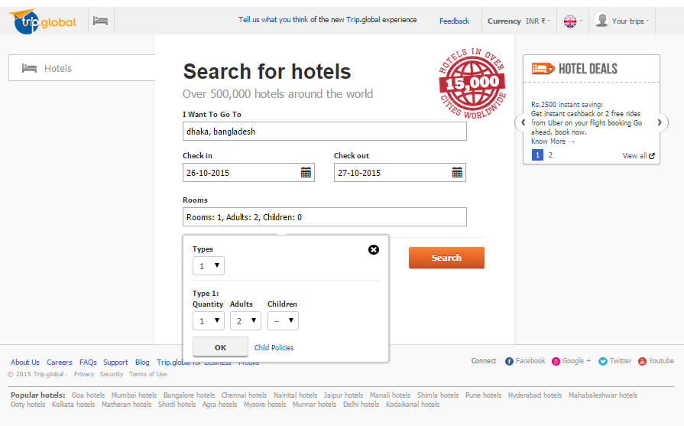
- 8.1.1 Screenshot with your params
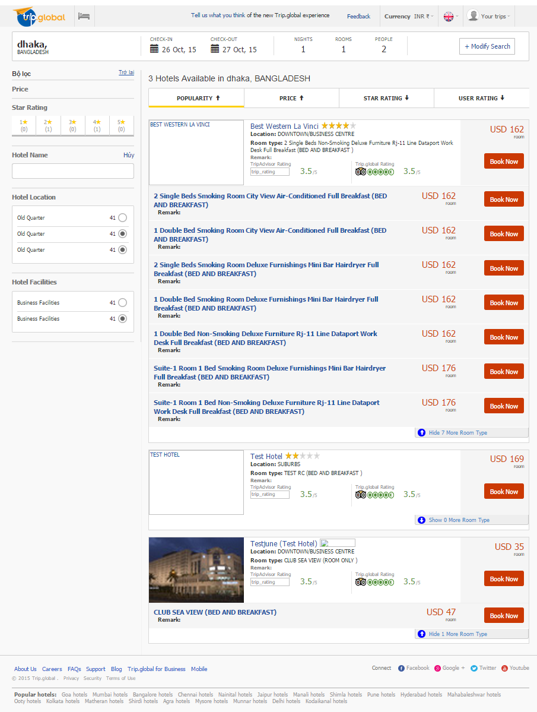
- 8.1.2 Screenshot hotel search response
- 8.2 Screenshot with booking info after Booking Insert
- 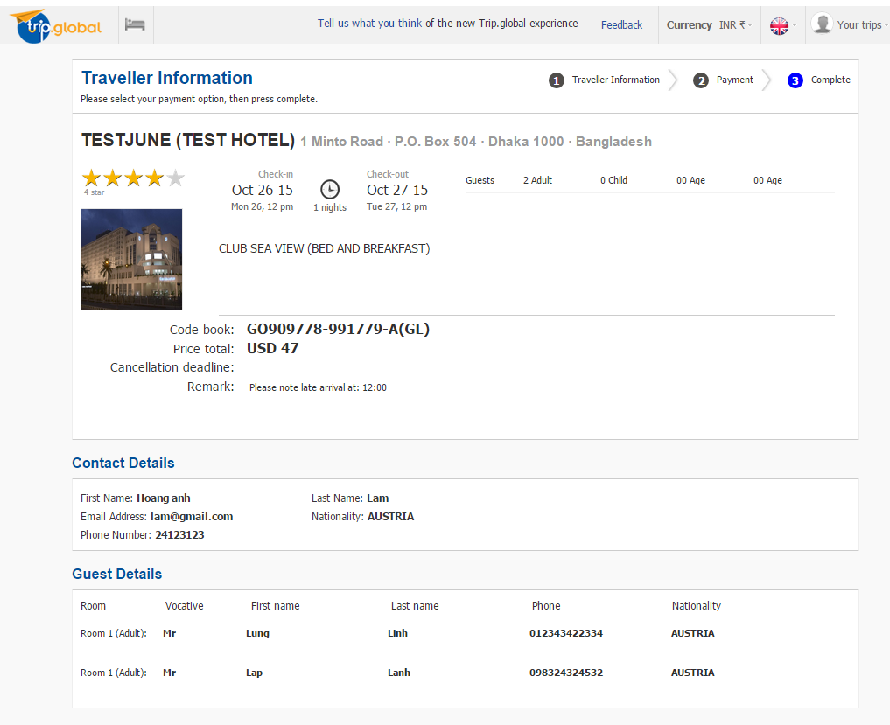
- 8.3 Screenshot with booking info after Booking Status
- 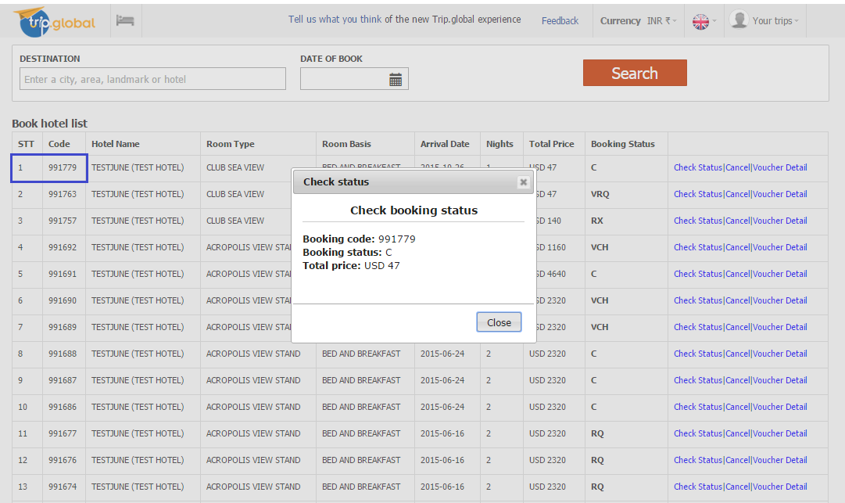
- 8.4 Screenshot with booking info after Voucher Req and Booking Status
- 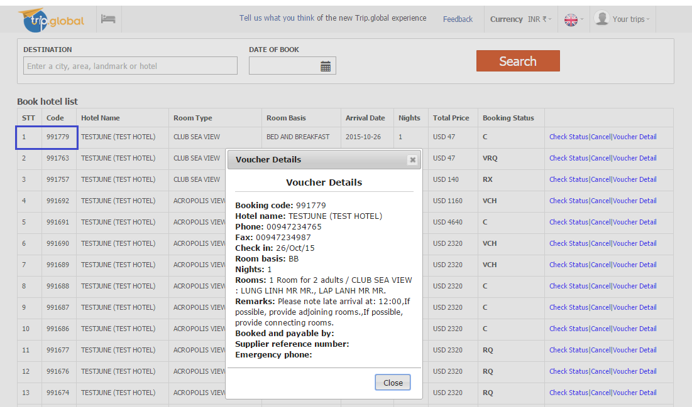
- 8.4.1 Screenshot voucher Req
- 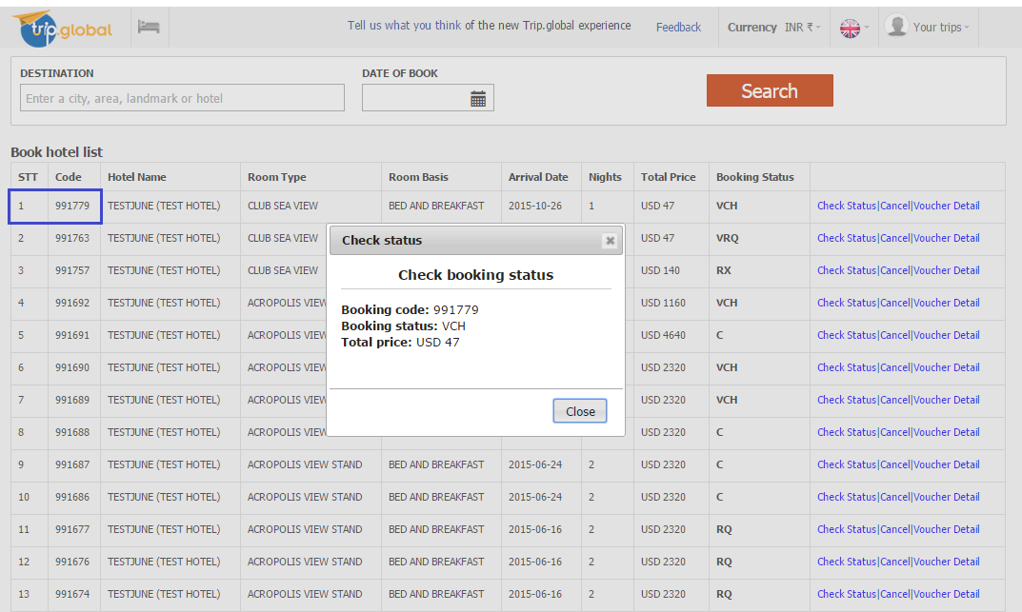
- 8.4.2 Screenshot booking Status

- 8.5 Screenshot with your voucher example
- 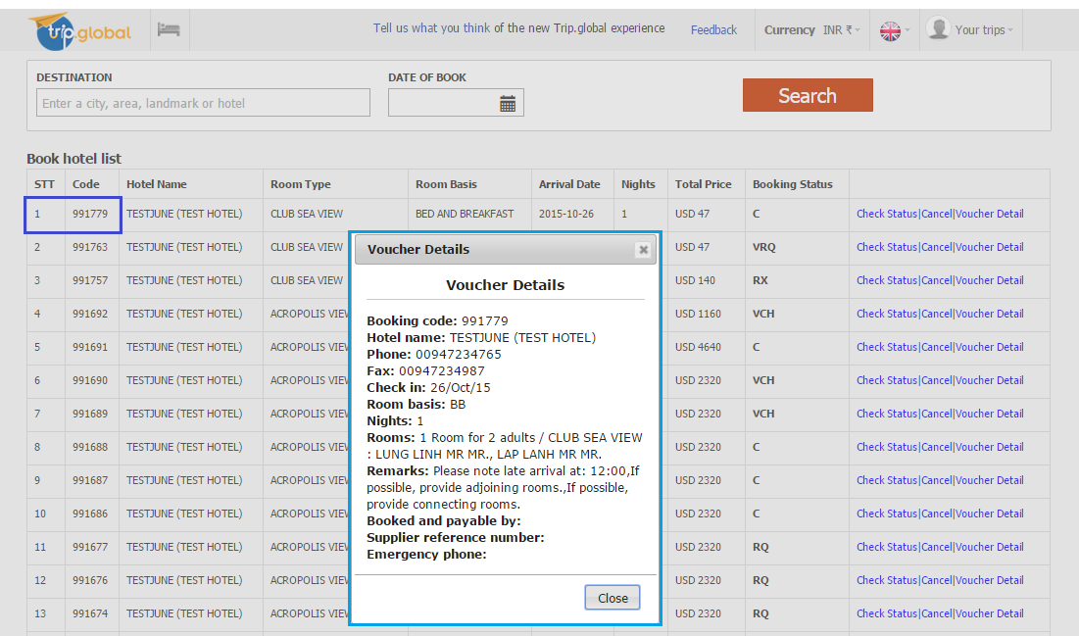
- Req/Res for the whole process.
- 8.1 Search xml
- a. Request xml
- <?xml version='1.0' encoding='utf-8'?>
- <soap:Envelope xmlns:xsi='http://www.w3.org/2001/XMLSchema-instance' xmlns:xsd='http://www.w3.org/2001/XMLSchema' xmlns:soap='http://schemas.xmlsoap.org/soap/envelope/'>
- <soap:Body>
- <MakeRequest xmlns='http://www.goglobal.travel/'>
- <requestType>11</requestType>
- <xmlRequest>
- <![CDATA[<Root> <Header><Agency>1521345</Agency><User>TRIPGLOBALXML</User><Password>XMLTRIPGLOBAL</Password><Operation>HOTEL_SEARCH_REQUEST</Operation><OperationType>Request</OperationType> </Header> <Main><SortOrder>0</SortOrder><FilterPriceMin>0</FilterPriceMin><FilterPriceMax>10000</FilterPriceMax><MaximumWaitTime>30</MaximumWaitTime><MaxResponses>1000</MaxResponses><FilterRoomBasises> <FilterRoomBasis></FilterRoomBasis></FilterRoomBasises><HotelName></HotelName><Apartments>false</Apartments><CityCode>3715</CityCode> <ArrivalDate>2015-10-26</ArrivalDate><Nights>1</Nights><Rooms><Room Adults='2' RoomCount='1'></Room> </Rooms> </Main> </Root>]]>
- </xmlRequest>
- </MakeRequest>
- </soap:Body>
- </soap:Envelope>

- b. Response xml
<?xml version="1.0" encoding="utf-8" ?>
<soap:Envelope xmlns:soap="http://schemas.xmlsoap.org/soap/envelope/" xmlns:xsi="http://www.w3.org/2001/XMLSchema-instance" xmlns:xsd="http://www.w3.org/2001/XMLSchema">
<soap:Body>
<MakeRequestResponse xmlns="http://www.goglobal.travel/">
<MakeRequestResult><Root><Header><Agency>1521345</Agency><User>TRIPGLOBALXML</User><Password>XMLTRIPGLOBAL</Password><Operation>HOTEL_SEARCH_RESPONSE</Operation><OperationType>Response</OperationType><Statistics><ResultsQty>11</ResultsQty></Statistics></Header><Main><Hotel><HotelSearchCode><![CDATA[220733/841947/0]]></HotelSearchCode><HotelCode><![CDATA[95509]]></HotelCode><HotelName><![CDATA[BEST WESTERN LA VINCI]]></HotelName><CountryId><![CDATA[139]]></CountryId><CxlDeadline><![CDATA[23/Oct/2015]]></CxlDeadline><RoomType><![CDATA[2 Single Beds Non-Smoking Deluxe Furniture Rj-11 Line Dataport Work Desk Full Breakfast]]></RoomType><RoomBasis><![CDATA[BB]]></RoomBasis><Availability><![CDATA[1]]></Availability><TotalPrice><![CDATA[162]]></TotalPrice><Currency><![CDATA[USD]]></Currency><Category><![CDATA[4]]></Category><Location><![CDATA[DOWNTOWN/BUSINESS CENTRE]]></Location><LocationCode><![CDATA[]]></LocationCode><Preferred><![CDATA[0]]></Preferred><Thumbnail><![CDATA[]]></Thumbnail><TripAdvisor><Rating></Rating><RatingImage><![CDATA[]]></RatingImage><ReviewCount></ReviewCount><Reviews><![CDATA[]]></Reviews></TripAdvisor></Hotel><Hotel><HotelSearchCode><![CDATA[220733/841947/1]]></HotelSearchCode><HotelCode><![CDATA[95509]]></HotelCode><HotelName><![CDATA[BEST WESTERN LA VINCI]]></HotelName><CountryId><![CDATA[139]]></CountryId><CxlDeadline><![CDATA[23/Oct/2015]]></CxlDeadline><RoomType><![CDATA[2 Single Beds Smoking Room City View Air-Conditioned Full Breakfast]]></RoomType><RoomBasis><![CDATA[BB]]></RoomBasis><Availability><![CDATA[1]]></Availability><TotalPrice><![CDATA[162]]></TotalPrice><Currency><![CDATA[USD]]></Currency><Category><![CDATA[4]]></Category><Location><![CDATA[DOWNTOWN/BUSINESS CENTRE]]></Location><LocationCode><![CDATA[]]></LocationCode><Preferred><![CDATA[0]]></Preferred><Thumbnail><![CDATA[]]></Thumbnail><TripAdvisor><Rating></Rating><RatingImage><![CDATA[]]></RatingImage><ReviewCount></ReviewCount><Reviews><![CDATA[]]></Reviews></TripAdvisor></Hotel><Hotel><HotelSearchCode><![CDATA[220733/841947/2]]></HotelSearchCode><HotelCode><![CDATA[95509]]></HotelCode><HotelName><![CDATA[BEST WESTERN LA VINCI]]></HotelName><CountryId><![CDATA[139]]></CountryId><CxlDeadline><![CDATA[23/Oct/2015]]></CxlDeadline><RoomType><![CDATA[1 Double Bed Smoking Room City View Air-Conditioned Full Breakfast]]></RoomType><RoomBasis><![CDATA[BB]]></RoomBasis><Availability><![CDATA[1]]></Availability><TotalPrice><![CDATA[162]]></TotalPrice><Currency><![CDATA[USD]]></Currency><Category><![CDATA[4]]></Category><Location><![CDATA[DOWNTOWN/BUSINESS CENTRE]]></Location><LocationCode><![CDATA[]]></LocationCode><Preferred><![CDATA[0]]></Preferred><Thumbnail><![CDATA[]]></Thumbnail><TripAdvisor><Rating></Rating><RatingImage><![CDATA[]]></RatingImage><ReviewCount></ReviewCount><Reviews><![CDATA[]]></Reviews></TripAdvisor></Hotel><Hotel><HotelSearchCode><![CDATA[220733/841947/3]]></HotelSearchCode><HotelCode><![CDATA[95509]]></HotelCode><HotelName><![CDATA[BEST WESTERN LA VINCI]]></HotelName><CountryId><![CDATA[139]]></CountryId><CxlDeadline><![CDATA[23/Oct/2015]]></CxlDeadline><RoomType><![CDATA[2 Single Beds Smoking Room Deluxe Furnishings Mini Bar Hairdryer Full Breakfast]]></RoomType><RoomBasis><![CDATA[BB]]></RoomBasis><Availability><![CDATA[1]]></Availability><TotalPrice><![CDATA[162]]></TotalPrice><Currency><![CDATA[USD]]></Currency><Category><![CDATA[4]]></Category><Location><![CDATA[DOWNTOWN/BUSINESS CENTRE]]></Location><LocationCode><![CDATA[]]></LocationCode><Preferred><![CDATA[0]]></Preferred><Thumbnail><![CDATA[]]></Thumbnail><TripAdvisor><Rating></Rating><RatingImage><![CDATA[]]></RatingImage><ReviewCount></ReviewCount><Reviews><![CDATA[]]></Reviews></TripAdvisor></Hotel><Hotel><HotelSearchCode><![CDATA[220733/841947/4]]></HotelSearchCode><HotelCode><![CDATA[95509]]></HotelCode><HotelName><![CDATA[BEST WESTERN LA VINCI]]></HotelName><CountryId><![CDATA[139]]></CountryId><CxlDeadline><![CDATA[23/Oct/2015]]></CxlDeadline><RoomType><![CDATA[1 Double Bed Smoking Room Deluxe Furnishings Mini Bar Hairdryer Full Breakfast]]></RoomType><RoomBasis><![CDATA[BB]]></RoomBasis><Availability><![CDATA[1]]></Availability><TotalPrice><![CDATA[162]]></TotalPrice><Currency><![CDATA[USD]]></Currency><Category><![CDATA[4]]></Category><Location><![CDATA[DOWNTOWN/BUSINESS CENTRE]]></Location><LocationCode><![CDATA[]]></LocationCode><Preferred><![CDATA[0]]></Preferred><Thumbnail><![CDATA[]]></Thumbnail><TripAdvisor><Rating></Rating><RatingImage><![CDATA[]]></RatingImage><ReviewCount></ReviewCount><Reviews><![CDATA[]]></Reviews></TripAdvisor></Hotel><Hotel><HotelSearchCode><![CDATA[220733/841947/5]]></HotelSearchCode><HotelCode><![CDATA[95509]]></HotelCode><HotelName><![CDATA[BEST WESTERN LA VINCI]]></HotelName><CountryId><![CDATA[139]]></CountryId><CxlDeadline><![CDATA[23/Oct/2015]]></CxlDeadline><RoomType><![CDATA[1 Double Bed Non-Smoking Deluxe Furniture Rj-11 Line Dataport Work Desk Full Breakfast]]></RoomType><RoomBasis><![CDATA[BB]]></RoomBasis><Availability><![CDATA[1]]></Availability><TotalPrice><![CDATA[162]]></TotalPrice><Currency><![CDATA[USD]]></Currency><Category><![CDATA[4]]></Category><Location><![CDATA[DOWNTOWN/BUSINESS CENTRE]]></Location><LocationCode><![CDATA[]]></LocationCode><Preferred><![CDATA[0]]></Preferred><Thumbnail><![CDATA[]]></Thumbnail><TripAdvisor><Rating></Rating><RatingImage><![CDATA[]]></RatingImage><ReviewCount></ReviewCount><Reviews><![CDATA[]]></Reviews></TripAdvisor></Hotel><Hotel><HotelSearchCode><![CDATA[220733/841947/6]]></HotelSearchCode><HotelCode><![CDATA[95509]]></HotelCode><HotelName><![CDATA[BEST WESTERN LA VINCI]]></HotelName><CountryId><![CDATA[139]]></CountryId><CxlDeadline><![CDATA[23/Oct/2015]]></CxlDeadline><RoomType><![CDATA[Suite-1 Room 1 Bed Smoking Room Deluxe Furnishings Mini Bar Hairdryer Full Breakfast]]></RoomType><RoomBasis><![CDATA[BB]]></RoomBasis><Availability><![CDATA[1]]></Availability><TotalPrice><![CDATA[176]]></TotalPrice><Currency><![CDATA[USD]]></Currency><Category><![CDATA[4]]></Category><Location><![CDATA[DOWNTOWN/BUSINESS CENTRE]]></Location><LocationCode><![CDATA[]]></LocationCode><Preferred><![CDATA[0]]></Preferred><Thumbnail><![CDATA[]]></Thumbnail><TripAdvisor><Rating></Rating><RatingImage><![CDATA[]]></RatingImage><ReviewCount></ReviewCount><Reviews><![CDATA[]]></Reviews></TripAdvisor></Hotel><Hotel><HotelSearchCode><![CDATA[220733/841947/7]]></HotelSearchCode><HotelCode><![CDATA[95509]]></HotelCode><HotelName><![CDATA[BEST WESTERN LA VINCI]]></HotelName><CountryId><![CDATA[139]]></CountryId><CxlDeadline><![CDATA[23/Oct/2015]]></CxlDeadline><RoomType><![CDATA[Suite-1 Room 1 Bed Non-Smoking Deluxe Furniture Rj-11 Line Dataport Work Desk Full Breakfast]]></RoomType><RoomBasis><![CDATA[BB]]></RoomBasis><Availability><![CDATA[1]]></Availability><TotalPrice><![CDATA[176]]></TotalPrice><Currency><![CDATA[USD]]></Currency><Category><![CDATA[4]]></Category><Location><![CDATA[DOWNTOWN/BUSINESS CENTRE]]></Location><LocationCode><![CDATA[]]></LocationCode><Preferred><![CDATA[0]]></Preferred><Thumbnail><![CDATA[]]></Thumbnail><TripAdvisor><Rating></Rating><RatingImage><![CDATA[]]></RatingImage><ReviewCount></ReviewCount><Reviews><![CDATA[]]></Reviews></TripAdvisor></Hotel><Hotel><HotelSearchCode><![CDATA[128562/841947/8]]></HotelSearchCode><HotelCode><![CDATA[97296]]></HotelCode><HotelName><![CDATA[TEST HOTEL]]></HotelName><CountryId><![CDATA[139]]></CountryId><CxlDeadline><![CDATA[18/Oct/2015]]></CxlDeadline><RoomType><![CDATA[TEST RC]]></RoomType><RoomBasis><![CDATA[BB]]></RoomBasis><Availability><![CDATA[1]]></Availability><TotalPrice><![CDATA[169]]></TotalPrice><Currency><![CDATA[USD]]></Currency><Category><![CDATA[2]]></Category><Location><![CDATA[SUBURBS]]></Location><LocationCode><![CDATA[24672]]></LocationCode><Preferred><![CDATA[0]]></Preferred><Thumbnail><![CDATA[]]></Thumbnail><TripAdvisor><Rating></Rating><RatingImage><![CDATA[]]></RatingImage><ReviewCount></ReviewCount><Reviews><![CDATA[]]></Reviews></TripAdvisor></Hotel><Hotel><HotelSearchCode><![CDATA[147172/841947/9]]></HotelSearchCode><HotelCode><![CDATA[88752]]></HotelCode><HotelName><![CDATA[TESTJUNE (TEST HOTEL)]]></HotelName><CountryId><![CDATA[139]]></CountryId><CxlDeadline><![CDATA[17/Jul/2015]]></CxlDeadline><RoomType><![CDATA[CLUB SEA VIEW]]></RoomType><RoomBasis><![CDATA[RO]]></RoomBasis><Availability><![CDATA[1]]></Availability><TotalPrice><![CDATA[35]]></TotalPrice><Currency><![CDATA[USD]]></Currency><Category><![CDATA[3.5]]></Category><Location><![CDATA[DOWNTOWN/BUSINESS CENTRE]]></Location><LocationCode><![CDATA[21240]]></LocationCode><Preferred><![CDATA[0]]></Preferred><Thumbnail><![CDATA[http://images.static.goglobal.travel/images/hotels/88752/88752_3t.jpg]]></Thumbnail><GeoCodes><Longitude><![CDATA[90.397]]></Longitude><Latitude><![CDATA[23.74128]]></Latitude></GeoCodes><TripAdvisor><Rating></Rating><RatingImage><![CDATA[]]></RatingImage><ReviewCount></ReviewCount><Reviews><![CDATA[]]></Reviews></TripAdvisor></Hotel><Hotel><HotelSearchCode><![CDATA[147171/841947/10]]></HotelSearchCode><HotelCode><![CDATA[88752]]></HotelCode><HotelName><![CDATA[TESTJUNE (TEST HOTEL)]]></HotelName><CountryId><![CDATA[139]]></CountryId><CxlDeadline><![CDATA[25/Oct/2015]]></CxlDeadline><RoomType><![CDATA[CLUB SEA VIEW]]></RoomType><RoomBasis><![CDATA[BB]]></RoomBasis><Availability><![CDATA[1]]></Availability><TotalPrice><![CDATA[47]]></TotalPrice><Currency><![CDATA[USD]]></Currency><Category><![CDATA[3.5]]></Category><Location><![CDATA[DOWNTOWN/BUSINESS CENTRE]]></Location><LocationCode><![CDATA[21240]]></LocationCode><Preferred><![CDATA[0]]></Preferred><Thumbnail><![CDATA[http://images.static.goglobal.travel/images/hotels/88752/88752_3t.jpg]]></Thumbnail><GeoCodes><Longitude><![CDATA[90.397]]></Longitude><Latitude><![CDATA[23.74128]]></Latitude></GeoCodes><TripAdvisor><Rating></Rating><RatingImage><![CDATA[]]></RatingImage><ReviewCount></ReviewCount><Reviews><![CDATA[]]></Reviews></TripAdvisor></Hotel></Main></Root></MakeRequestResult>
</MakeRequestResponse>
</soap:Body>
- </soap:Envelope>
- 8.2 Booking Insert
- a. Request xml
<?xml version="1.0" encoding="utf-8" ?>
<soap:Envelope xmlns:xsi="http://www.w3.org/2001/XMLSchema-instance" xmlns:xsd="http://www.w3.org/2001/XMLSchema" xmlns:soap="http://schemas.xmlsoap.org/soap/envelope/">
<soap:Body>
<MakeRequest xmlns="http://www.goglobal.travel/">
<requestType>2</requestType>
<xmlRequest>
<![CDATA[ <Root> <Header> <Agency>1521345</Agency><User>TRIPGLOBALXML</User><Password>XMLTRIPGLOBAL</Password><Operation>BOOKING_INSERT_REQUEST</Operation><OperationType>Request</OperationType> </Header> <Main><AgentReference>TRIPGLOBALXML</AgentReference><HotelSearchCode>147171/841950/10</HotelSearchCode><ArrivalDate>2015-10-26</ArrivalDate><Nights>1</Nights><NoAlternativeHotel>1</NoAlternativeHotel><Leader LeaderPersonID='1'/><Rooms> <RoomType Adults='2' > <Room RoomID='1'><PersonName PersonID='1'>Lung Linh Mr </PersonName><PersonName PersonID='2'>Lap Lanh Mr </PersonName></Room></RoomType> </Rooms><Preferences> <LateArrival>12:00</LateArrival> <AdjoiningRooms>1</AdjoiningRooms> <ConnectingRooms>1</ConnectingRooms></Preferences><Remark></Remark> </Main></Root>]]>
</xmlRequest>
</MakeRequest>
</soap:Body>
- </soap:Envelope>
- b. Response xml
<?xml version="1.0" encoding="utf-8" ?>
<soap:Envelope xmlns:soap="http://schemas.xmlsoap.org/soap/envelope/" xmlns:xsi="http://www.w3.org/2001/XMLSchema-instance" xmlns:xsd="http://www.w3.org/2001/XMLSchema">
<soap:Body>
<MakeRequestResponse xmlns="http://www.goglobal.travel/">
<MakeRequestResult><Root><Header><Agency>1521345</Agency><User>TRIPGLOBALXML</User><Password>XMLTRIPGLOBAL</Password><Operation>BOOKING_INSERT_RESPONSE</Operation><OperationType>Response</OperationType></Header><Main><GoBookingCode>991779</GoBookingCode><GoReference>GO909778-991779-A(GL)</GoReference><ClientBookingCode>TRIPGLOBALXML</ClientBookingCode><BookingStatus>C</BookingStatus><TotalPrice>47</TotalPrice><Currency>USD</Currency><HotelName><![CDATA[TESTJUNE (TEST HOTEL)]]></HotelName><HotelSearchCode>147171/841950/10</HotelSearchCode><RoomType><![CDATA[CLUB SEA VIEW]]></RoomType><RoomBasis><![CDATA[BB]]></RoomBasis><ArrivalDate>2015-10-26</ArrivalDate><CancellationDeadline>2015-10-25</CancellationDeadline><Nights>1</Nights><NoAlternativeHotel>1</NoAlternativeHotel><Leader LeaderPersonID="1"/><Rooms><RoomType Adults="2" ><Room RoomID="1"><PersonName PersonID="1">LUNG LINH MR</PersonName><PersonName PersonID="2">LAP LANH MR</PersonName></Room></RoomType></Rooms><Preferences><AdjoiningRooms><![CDATA[1]]></AdjoiningRooms><ConnectingRooms><![CDATA[1]]></ConnectingRooms><LateArrival><![CDATA[12:00]]></LateArrival></Preferences><Remark><![CDATA[Please note late arrival at: 12:00, If possible, provide adjoining rooms., If possible, provide connecting rooms.]]></Remark></Main></Root></MakeRequestResult>
</MakeRequestResponse>
</soap:Body>
- </soap:Envelope>
- 8.3 Booking Status
- a. Request xml
<?xml version="1.0" encoding="utf-8" ?>
<soap:Envelope xmlns:xsi="http://www.w3.org/2001/XMLSchema-instance" xmlns:xsd="http://www.w3.org/2001/XMLSchema" xmlns:soap="http://schemas.xmlsoap.org/soap/envelope/">
<soap:Body>
<MakeRequest xmlns="http://www.goglobal.travel/">
<requestType>5</requestType>
<xmlRequest>
<![CDATA[ <Root> <Header> <Agency>1521345</Agency><User>TRIPGLOBALXML</User><Password>XMLTRIPGLOBAL</Password><Operation>BOOKING_STATUS_REQUEST</Operation><OperationType>Request</OperationType> </Header> <Main><GoBookingCode>991779</GoBookingCode></Main></Root>]]>
</xmlRequest>
</MakeRequest>
</soap:Body>
</soap:Envelope>
- b. Response xml
<?xml version="1.0" encoding="utf-8" ?>
<soap:Envelope xmlns:xsi="http://www.w3.org/2001/XMLSchema-instance" xmlns:xsd="http://www.w3.org/2001/XMLSchema" xmlns:soap="http://schemas.xmlsoap.org/soap/envelope/">
<soap:Body>
<MakeRequest xmlns="http://www.goglobal.travel/">
<requestType>5</requestType>
<xmlRequest>
<![CDATA[ <Root> <Header> <Agency>1521345</Agency><User>TRIPGLOBALXML</User><Password>XMLTRIPGLOBAL</Password><Operation>BOOKING_STATUS_REQUEST</Operation><OperationType>Request</OperationType> </Header> <Main><GoBookingCode>991779</GoBookingCode></Main></Root>]]>
</xmlRequest>
</MakeRequest>
</soap:Body>
- </soap:Envelope>
- 8.4 Voucher Req
- a. Request xml
<?xml version="1.0" encoding="utf-8" ?>
<soap:Envelope xmlns:xsi="http://www.w3.org/2001/XMLSchema-instance" xmlns:xsd="http://www.w3.org/2001/XMLSchema" xmlns:soap="http://schemas.xmlsoap.org/soap/envelope/">
<soap:Body>
<MakeRequest xmlns="http://www.goglobal.travel/">
<requestType>8</requestType>
<xmlRequest>
<![CDATA[ <Root> <Header> <Agency>1521345</Agency><User>TRIPGLOBALXML</User><Password>XMLTRIPGLOBAL</Password><Operation>VOUCHER_DETAILS_REQUEST</Operation><OperationType>Request</OperationType> </Header> <Main><GoBookingCode>991779</GoBookingCode></Main></Root>]]>
</xmlRequest>
</MakeRequest>
</soap:Body>
- </soap:Envelope>
- b. Response xml
<?xml version="1.0" encoding="utf-8" ?>
<soap:Envelope xmlns:soap="http://schemas.xmlsoap.org/soap/envelope/" xmlns:xsi="http://www.w3.org/2001/XMLSchema-instance" xmlns:xsd="http://www.w3.org/2001/XMLSchema">
<soap:Body>
<MakeRequestResponse xmlns="http://www.goglobal.travel/">
<MakeRequestResult><Root><Header><Agency>1521345</Agency><User>TRIPGLOBALXML</User><Password>XMLTRIPGLOBAL</Password><Operation>VOUCHER_DETAILS_RESPONSE</Operation><OperationType>Response</OperationType></Header><Main><GoBookingCode><![CDATA[991779]]></GoBookingCode><HotelName><![CDATA[TESTJUNE (TEST HOTEL)]]></HotelName><Address><![CDATA[1 Minto Road · P.O. Box 504 · Dhaka 1000 · Bangladesh]]></Address><Phone><![CDATA[00947234765]]></Phone><Fax><![CDATA[00947234987]]></Fax><CheckInDate><![CDATA[26/Oct/15]]></CheckInDate><RoomBasis><![CDATA[BB]]></RoomBasis><Nights><![CDATA[1]]></Nights><Rooms><![CDATA[1 Room for 2 adults / CLUB SEA VIEW : LUNG LINH MR MR., LAP LANH MR MR.]]></Rooms><Remarks><![CDATA[Please note late arrival at: 12:00,If possible, provide adjoining rooms.,If possible, provide connecting rooms.]]></Remarks><BookedAndPayableBy><![CDATA[]]></BookedAndPayableBy><SupplierReferenceNumber><![CDATA[]]></SupplierReferenceNumber></Main></Root></MakeRequestResult>
</MakeRequestResponse>
</soap:Body>
</soap:Envelope>
- 8.5 Booking Status
- a. Request xml
<?xml version="1.0" encoding="utf-8" ?>
<soap:Envelope xmlns:xsi="http://www.w3.org/2001/XMLSchema-instance" xmlns:xsd="http://www.w3.org/2001/XMLSchema" xmlns:soap="http://schemas.xmlsoap.org/soap/envelope/">
<soap:Body>
<MakeRequest xmlns="http://www.goglobal.travel/">
<requestType>5</requestType>
<xmlRequest>
<![CDATA[ <Root> <Header> <Agency>1521345</Agency><User>TRIPGLOBALXML</User><Password>XMLTRIPGLOBAL</Password><Operation>BOOKING_STATUS_REQUEST</Operation><OperationType>Request</OperationType> </Header> <Main><GoBookingCode>991779</GoBookingCode></Main></Root>]]>
</xmlRequest>
</MakeRequest>
</soap:Body>
- </soap:Envelope>
- b. Response xml
<?xml version="1.0" encoding="utf-8" ?>
<soap:Envelope xmlns:soap="http://schemas.xmlsoap.org/soap/envelope/" xmlns:xsi="http://www.w3.org/2001/XMLSchema-instance" xmlns:xsd="http://www.w3.org/2001/XMLSchema">
<soap:Body>
<MakeRequestResponse xmlns="http://www.goglobal.travel/">
<MakeRequestResult><Root><Header><Agency>1521345</Agency><User>TRIPGLOBALXML</User><Password>XMLTRIPGLOBAL</Password><Operation>BOOKING_STATUS_RESPONSE</Operation><OperationType>Response</OperationType></Header><Main><GoBookingCode Status="VCH" GoReference="GO909778-991779-A(GL)" TotalPrice="47" Currency="USD" Service="Hotels">991779</GoBookingCode></Main></Root></MakeRequestResult>
</MakeRequestResponse>
</soap:Body>
- </soap:Envelope>
TP #9 Hotel Info
Objective: check Hotel Info.
Description:
- Execute HOTEL_SEARCH_REQUEST method with the below params:
- Execute HOTEL_INFO_REQUEST method using HotelSearchCode.value.
Destination: DHAKA/ City Code=3715 (BANGLADESH)
Check In: 26/10/2015
Nights: 1
Room(s): 2 adults
Hotel Name: “BEST WESTERN LEIDSE SQUARE” (hotel code: 268)

Please make sure to add -
- Screenshot with your params and the hotel from the returned Hotel search response
- Screenshot with the Hotel information
*** Please Do not book this hotel!!! ***

